School of Technology, Business and Arts
University of Suffolk

MSc Computer Science

Student ID:
Module: DevOps – Component 2
Assessment: Ipswich Retail DevOps Case Study Report
Table of Contents
1. Introduction 4
2. Planning 5
3. Modular Architecture (MVT) 12
3.1 User Interface Wireframes 12
4. Automated CI/CD Pipeline 18
5. Containerization 20
5.1 Local development with Docker Compose 21
5.2 Containerisation and Operational Reliability 22
6. Testing 24
6.1 Running in CI (already configured) 26
7. Continuous Delivery (CD) 27
7.1 Tools Used to Implement Continuous Delivery 27
7.2 Continuous Delivery Workflow 27
7.3 Deployment Safety and Rollback 27
7.4 Auditability and Traceability 27
8. Monitoring and Logging 29
8.1 Logging strategy 29
8.2 Using Render logs 30
8.3 Health and readiness 30
8.4 Minimal metrics without extra tooling 30
8.5 Worksflow incident and alerts. 30
8.6 Log hygiene and privacy 30
8.7 Common log patterns and fixes 30
Summary 32
References 34

1. Introduction
Ipswich Retail has a narrowly coupled monolithic e-commerce system where presentation, business logic, and data access go hand in hand. This has the effect of making small changes slow, risky and difficult to independently test. It's architecture causing long deployment times, fragile manual releases and poor failure visibility which affects scalability and responsiveness. The system is poorly scaled, is deployed manually, has high downtime and not fully integrated among development and operations. DevOps solves such problems by use of automated CI/CD pipelines, containerization, environment-driven configuration to alleviate drift and joint workflows in development and operations. Improved tracing, documentation, version control, trunk-based development allow faster updates to the platform (safer) (Forsgren et al.,2018).
This report describes a containerized e-commerce application using Django that offers layer architecture Business logic, UI, and Data Persistence. Using automated CI/CD, docker and Render's free tier it addresses the issue of the monolith by facilitating easier, safer updates as well as greater operational awareness (Docker, Inc., 2025; OWASP, 2025). Its codebase is around one domain, shop, with product catalog, cart and order management. The stack consists of Django 5, Gunicorn, WhiteNoise, PostgreSQL, and TailwindCSS with environment-dependent settings so that it is portable (Django Software Foundation, 2025).

2. Planning
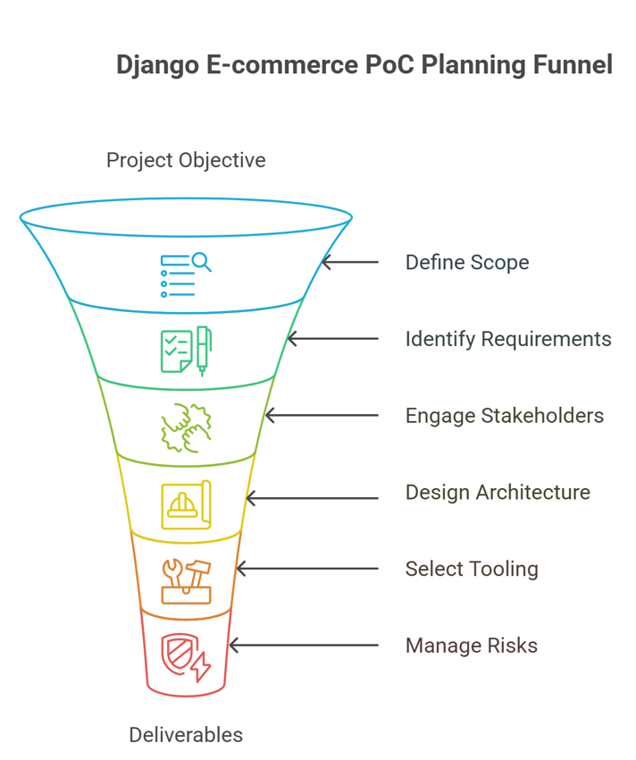
Figure 1 Django E-commerce PoC planning funnel, scope, requirements, stakeholders, architecture, tooling, and risk management (Sketching, 2017).
2.1 Objectives & Scope
The project aims to demonstrate a production-ready DevOps workflow through a Django e-commerce PoC.
The application functionalities will concern the main e-commerce needs:
- In Scope: The following are present: Public-facing product and category browsing, session-based shopping cart (add, update, remove items) and a checkout stub, which generates an order record. Category, Product, Cart, and Order models (with order items), have full CRUD (Create, Read, Update, Delete) access to the Django admin interface.
- Out of Scope: The DevOps pipeline is a specific project, and thus complex features are explicitly left out. This involves real-time payment processing, sophisticated promotion-code processing, and third-party system integration such as an ERP which would otherwise be stubbed (when needed).
2.2 Requirements
Functional Requirements
Catalog | The customer should have the option of browsing and sorting the products according to their categories.
Cart | Users must be able to add, update, and delete items in their cart. Adds up to user's session.
Checkout | It is a requirement that the checkout process creates a new Order in the database, and that is successful.
Admin | An administrator needs to be able to manage the catalog of products, and be able to view submitted orders using the Django admin.
UI | The user interface is required to be responsive as well as functional and is built using TailwindCSS - on both desktop and mobile.
Non-Functional Requirements
Deployment | The application must start reliably from a single, immutable Docker image.
Performance | Under light load, the p95 response time should remain under 500ms.
Security | DEBUG mode must be set to False in production. All configuration must be driven by environment variables.
Parity | The exact same container image must be used in development, CI, and production.
Operations | The production environment (Render) must provide access to application logs. A health check endpoint must be available. Database migrations must run automatically on deployment(Render,2025).
2.3 Stakeholders & Roles
This project involves several key roles, which may be fulfilled by the same individual in a PoC:
Developer | Responsible for making an application feature and writing appropriate tests.
DevOps Engineer | In charge of developing the Dockerfile and running the CI/CD pipeline as well as setting up the deployment environment.
QA/Tester | Responsible for light smoke test and ensuring end to end user flows are functioning.
Operations | Responsible for managing environment variables, and monitoring logs and doing rollbacks if necessary.
2.4 Architecture Overview
The application follows a standard Django MVT (Model-View-Template) architecture. Domain logic is encapsulated within the shop app. Routing is handled by the main ecommerce_project/urls.py file, which includes the app-specific shop/urls.py. Django templates are stored in both the global templates/ directory and the app-specific shop/templates/shop/ directory.
For persistence, the application uses PostgreSQL in production (with SQLite as a fallback for local development). WhiteNoise is used to serve static files directly from the Gunicorn server, and a persistent disk (on Render) is used for user-uploaded media files (Gunicorn,2025).
2.5 Project Structure
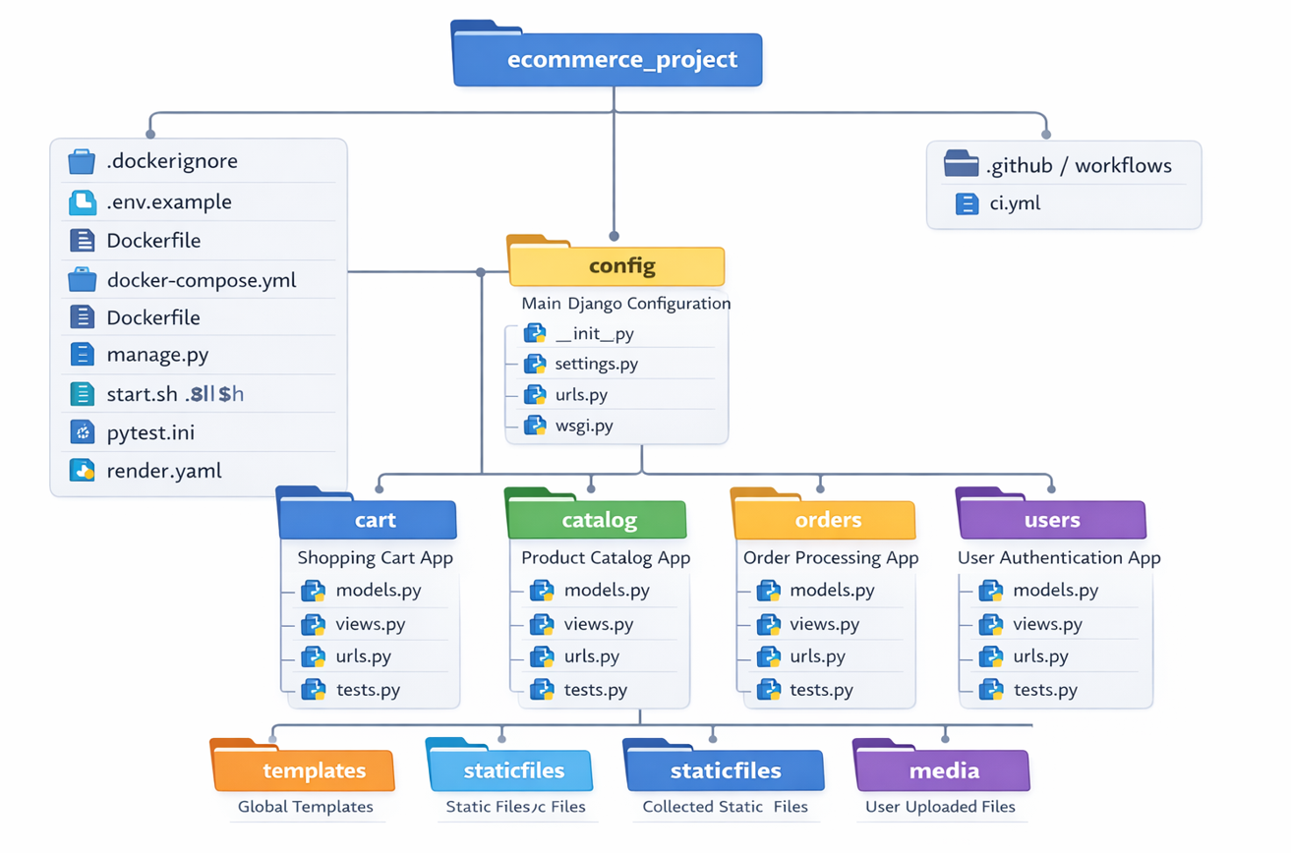
Figure 2: Django e-commerce application structure showing the main configuration (config/)
Four Django apps (cart, catalog, orders, users), Docker configuration files, CI/CD pipeline (.github/workflows/ci.yml), and static/media directories. The modular app structure follows Django best practices for separation of concerns.
2.6 Tooling Rationale
Django 5: | It is a good choice since it has a solid MVT framework, is equipped with an inbuilt administration, and its authentication/security capabilities are well developed.
PostgreSQL | I chose it as the production database is because it is reliable and easily managed on the Render platform.
TailwindCSS | It is an application that has been used due to its utility-based method of creating a responsive interface in a short period.
Docker | Will enable the reproducible, immutable image that can be used to ensure parity in the environment.
GitHub (Actions + GHCR) | This combines version control (Git), CI/CD (Actions), and image container storage (GitHub Container Registry) into one platform, which moved the tooling to built-in caching and provenance.
Render (Free Tier) | The provider has been selected due to its considerable free tier, managed web service, and PostgreSQL, inclusive of deploy history, and onboard logs.
2.7 Environment Strategy
Local:
Developers can start the web and db services with the help of docker-compose.yml. CRM is configured through a local.env file. Migrations and tests would be run within the container.
CI (GitHub Actions):
It is a pipeline, which is run in an empire environment that spins up a PostgreSQL service container to test on. GitHub is used to inject secrets in a secure way (GitHub, 2025).
Production (Render):
Deploys using the image from GHCR (or builds from Dockerfile). Config is provided in the form of environment variables of Render. The startup command starts the collectstatic and migrate automatically and then starts the Gunicorn server with WhiteNoise.
2.8 Configuration & Secrets
Any configuration that is environment-specific is handled through the use of environment variables and follows the principles of the Twelve-Factor App (Twelve-Factor App (n.d.) . This includes SECRET_KEY, DEBUG, ALLOWED_HOSTS, CSRF_TRUSTED_ORIGINS, and DATABASE_URL. This is available in a repository env.example file which also gives Workshop local settings. There is no time when secrets or credentials are saved to version control.
2.9 Delivery & Release Strategy
The project will have a development model with a trunk-based development and a protected main branch where all the changes must go through CI check through a pull request. The main workflow activated by the merging to main is the production build and deployment workflow. Each image has the latest and an immutable tag with the commit SHA attached to it so that they can be traced. The platform of Render has the history of deployment, which provides the option of one-click rollback(Render, 2025).
2.10 Risks & Mitigations
Risks | Mitigations
Free-tier limits (CPU/RAM). | Queries are kept simple, middleware is kept lean, and database pooling is used.
Platform cold starts causing slow initial loads. | A health check endpoint is provided for warm-up, and the application startup process is kept minimal.
Bad database migrations breaking production. | Migrations are designed to be backward-compatible. A fast rollback to the previous working Docker image is the primary recovery mechanism.
Loss of user-uploaded media on deploy. | A persistent disk is attached on Render to store the /media/ directory, though trade-offs in backup and scaling are noted.
Security vulnerabilities. | Standard Django security practices are enforced, DEBUG=False in prod, strict ALLOWED_HOSTS and CSRF_TRUSTED_ORIGINS, and rotation of secrets via environment variables, with no secrets ever appearing in logs (Kim et al.,2016).
2.11 The Need for Adopting DevOps
The existing system at Ipswich Retail has been associated with manual deployments, lack of cooperation between the development and operations, slow and unreliable release cycles, resulting in more downtime and reduced efficiency (GitHub, 2025). These silos result in divergent priorities between the developers and the operations, where developers are interested in features and operations are interested in stability and friction may follow. DevOps solutions to these inefficiencies include merging the teams into a single workflow, bringing in a Continuous Integration and Delivery (CI/CD) model that enables quicker, automated deployments, containerization and infrastructure-as-code, to maintain environmental consistency, and shared responsibility as a culture (Reitz et al., 2025). This does not only hasten release times and enhances reliability but also creates cooperation and ongoing enhancement that Devops is an organizational need and not a case of technical enhancement (Render, 2025).

3. Modular Architecture (MVT)

3.1 User Interface Wireframes
The planning stage involved low-fidelity wireframes that were used to visualise the interface and ensure the functional requirements were met before development. These wireframes will be the primary user flows of the ShopHub e-commerce app and will be consistent with the actual interface (Django Software Foundation, 2025).
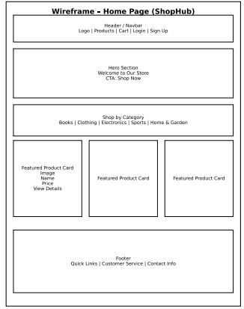
Figure 3: Home Page wireframe

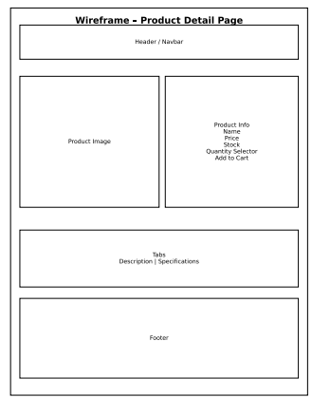
Figure 4: Product Detail Page wireframe
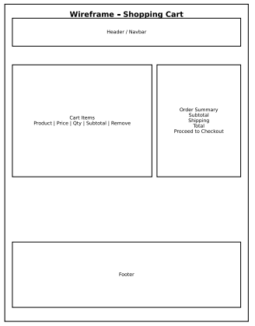
Figure 5: Shopping Cart wireframe
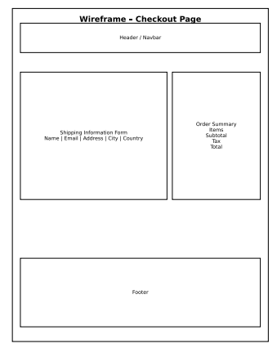
Figure 6: Checkout Page wireframe
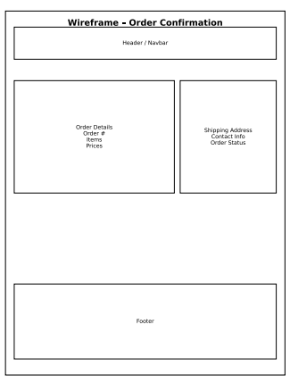
Figure 7: Order Confirmation wireframe
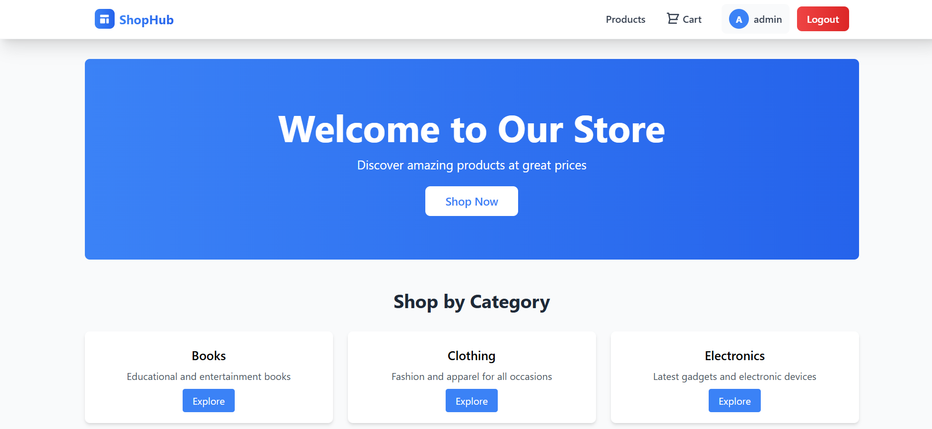
Figure 8: Home page on the ShopHub
Online store, which has a friendly introductory banner with a call-to-action button, a product, cart, and administration menu, and categories (Books, Clothing, Electronics) that give users an opportunity to navigate to various parts of the store.
Structure: Thin project layer (ecommerce/) + single domain app (shop/). Clear split of Models (data), Views (requests), Templates (presentation).
Models (shop/models.py):
Category(name, slug*), Product(category→FK, name, slug*, price[Decimal], stock, image, is_active, timestamps),
Cart(session_key*), CartItem(cart→FK, product→FK, quantity; unique(cart, product)),
Order(user?→FK, email, total_amount, status: created|paid|shipped|cancelled),
OrderItem(order→FK, product→FK snapshot, unit_price, quantity, line_total).
Constraints: unique slugs; qty ≥ 1; line_total = unit_price * quantity. Index on slug/category/is_active.
Views & URLs:
Catalog: list (by category, paginated) + detail (by slug).
Cart: add/update/remove + detail.
Checkout: creates Order from Cart (payment stub).
ecommerce/urls.py includes shop/urls.py with named routes.
Templates:
Base in templates/; pages in shop/templates/shop/ (product_list, product_detail, cart, checkout, order_confirmation). Tailwind; inheritance for DRY.
Admin:
All models registered; filters/search; OrderItem inline; totals read-only.
Cart/session:
Cart keyed to request.session.session_key; upsert (cart, product); revalidate stock on change; survives login.
Order flow:
Validate → create Order(status=created) → snapshot OrderItems with current prices → compute total_amount → clear cart.
Static/Media & Ops:
WhiteNoise serves staticfiles/; uploads in media/ (Render disk).
Prod hardening: DEBUG=False, strict ALLOWED_HOSTS/CSRF_TRUSTED_ORIGINS; paginate lists; use select_related/prefetch_related.

4. Automated CI/CD Pipeline
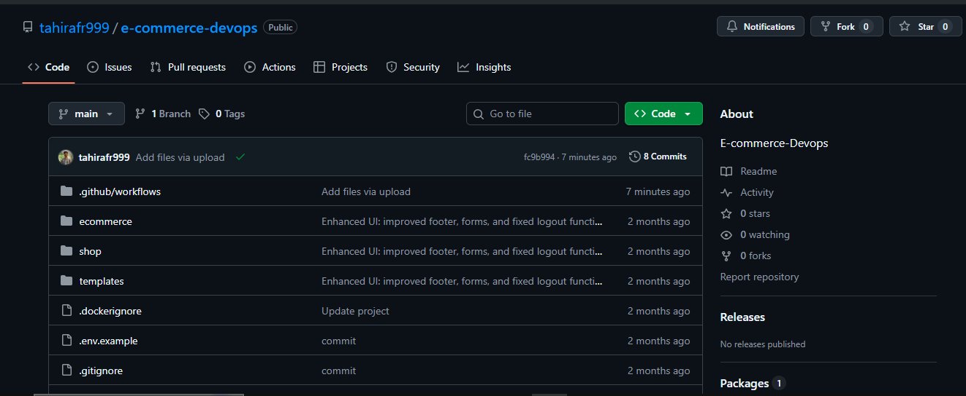
Figure 9: GitHub repository structure for the Django e-commerce project, including workflows, core apps, deployment files, and configuration assets.
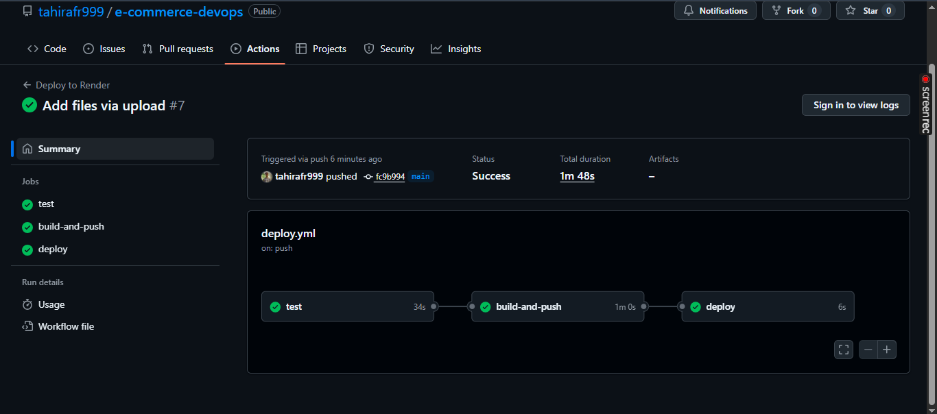
Figure 10: Successful CI/CD pipeline run on GitHub Actions
Triggers:
- PR to main: tests only.
- Push to main: test → build & push image → deploy.
Stages:
- Test: Postgres 15 service; set DATABASE_URL; migrate + test.
- Build/Publish: Buildx; login to GHCR; push tags latest and sha-<commit> with cache (type=gha).
- Deploy: Call Render API with RENDER_API_KEY and RENDER_SERVICE_ID; container starts, runs migrate + collectstatic, then Gunicorn.
Rollback:
Rollback previous image, which has already been successful by SHA in Render ( immutable artifacts = fast and safe rollback).
Practically, the installation of the CI/CD pipeline, at first, resulted in the exposure of configuration difficulties that could not be observed locally (i.e. database lossage when PostgreSQL was triggered as a distinct service container within GitHub Actions). Failure of running pipeline and detailed job logs were used as diagnoses of these problems resulting in missing or wrong environment variables. Once configurations were narrowed to the DATABASE URL and secret handling, the pipeline was ready to work consistently and with every push to main, a quick feedback about the status of deployability of the application is intensified (Humble and Farley, 2010).

5. Containerization
The application ships as a single Docker image (Python 3.11-slim) designed for predictable, repeatable deployments across local (Compose), CI, and Render. The image runs Django with Gunicorn and WhiteNoise, applies migrations at startup, optionally creates an admin user, then serves HTTP traffic on port 8000 (WhiteNoise, 2025) .
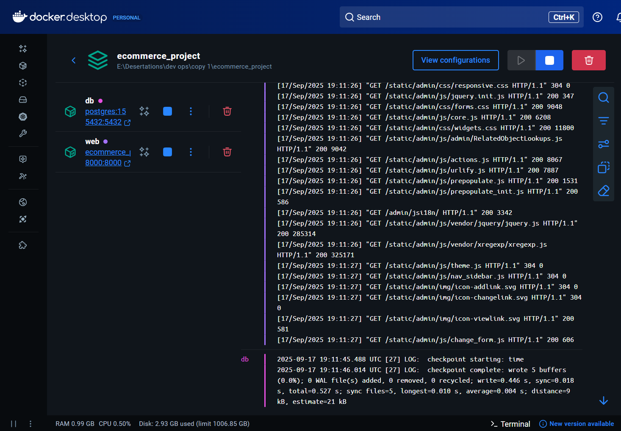
Figure 11: Docker Desktop view of the e-commerce project running with PostgreSQL and web containers, along with live logs.
This was shipped as a single non-mutable Docker container, all the environment-specific configurations being injected at runtime. This way ensured parity between development, CI as well as production environments and avoided the drift of configuration, it allowed reliably promoting the same artifact across the DevOps pipeline.
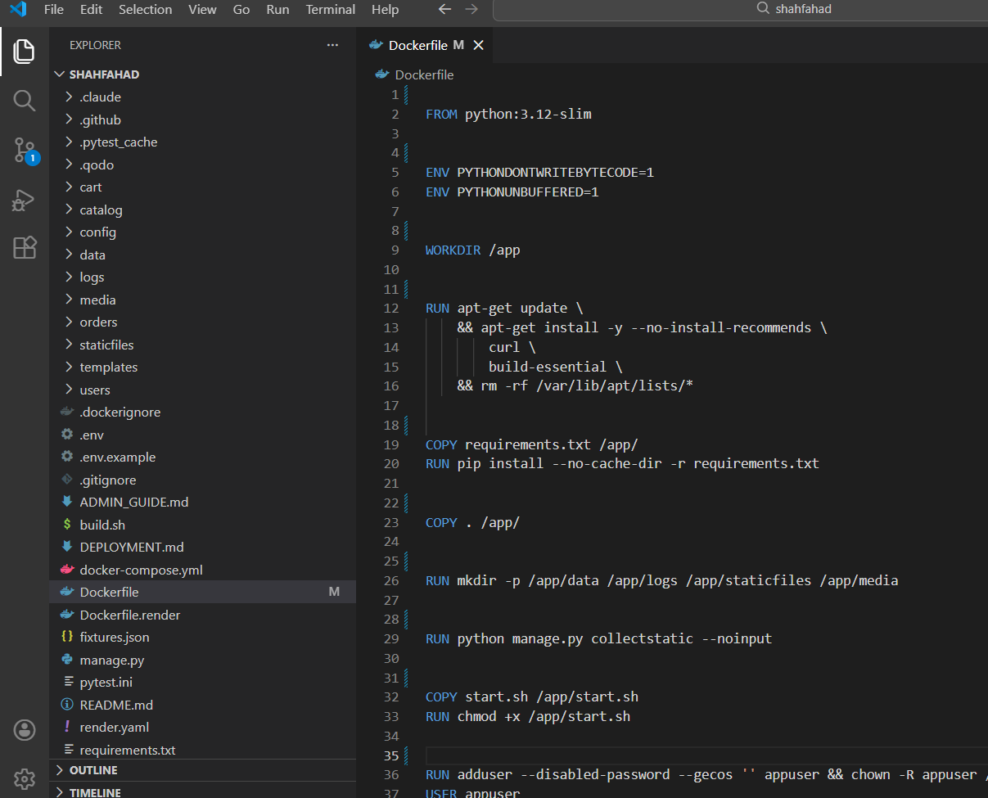
Figure 12: Configuration showing python:3.12-slim base image used to minimize container size and attack surface, demonstrating best practices for production Docker images.

5.1 Local development with Docker Compose
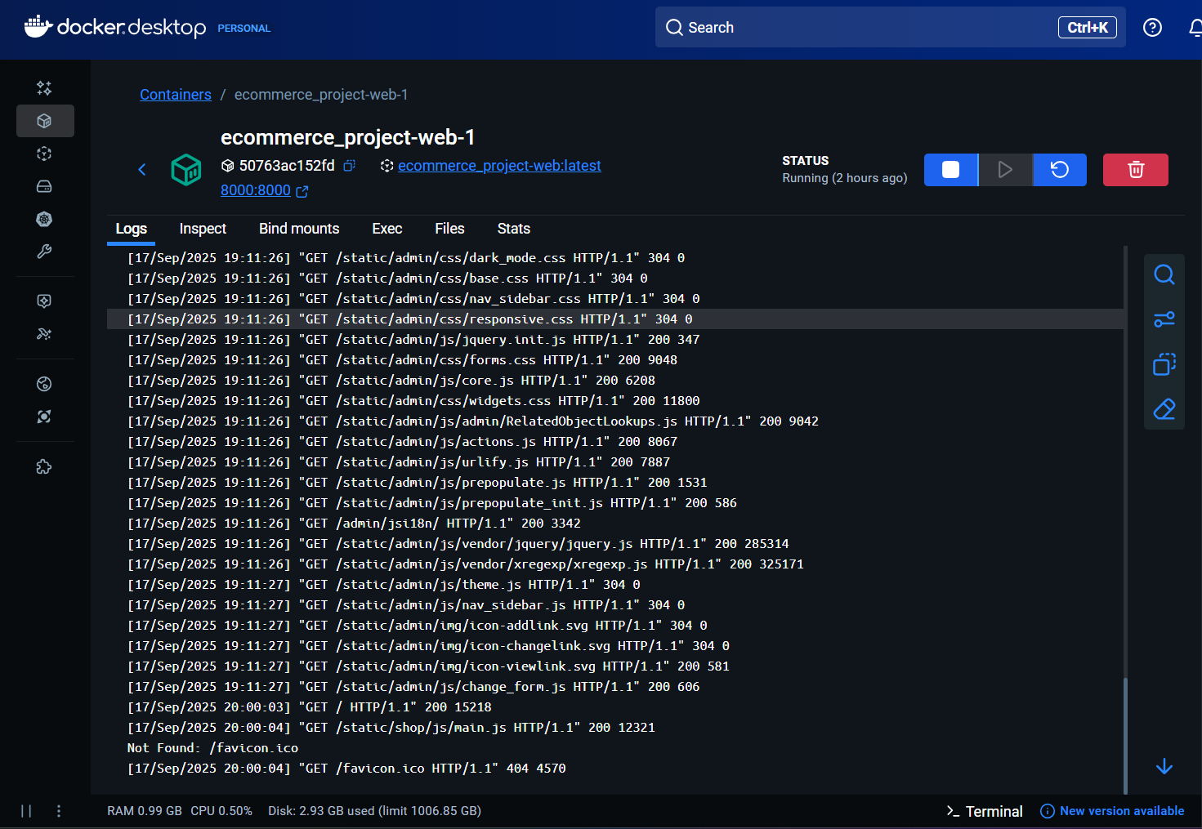
Figure 13: Docker container logs
It is for the local development environment, where the ecommerce_project-web-1 service is running and actively serving static files, confirming that the Django application is functioning correctly inside Docker.
Health checks (recommended):
- Add a small /health/ view that returns 200 OK.
- In Compose, configure a healthcheck for the web to curl that endpoint.
The container construction to increase reliability and develop performance was enhanced by using the slender base image, versioned image tags, and stashed constructs. The proof of the concept did not require any external dependencies, so the startup gathered the static assets and gave them to the application to serve them on the front end.

5.2 Containerisation and Operational Reliability
Before the advent of containerisation, applications would often fail because of dissimilarity in the operating systems, libraries installed, runtime dependencies, or configuration incompatibilities, oftentimes known as it works on my machine (Pahl, 2015). Containerisation assigns the application and its runtime environment, system libraries and dependencies to an immutable containerised image to guarantee that the application executes predictably and reproducibly together with all the pipeline stages.
Containerisation in the ShopHub e-commerce project decouples application runtime behaviour and the underlying infrastructure, and allows the identification of failures at the boundary of a container instead of the underlying heterogeneity of host systems. Such isolation makes troubleshooting easier since one can be confident that the issue with build-time, startup, and run time is a configuration or dependency problem, not an environmental difference. Consequently, debugging can be more systematic and faster, enhance the mean time to recover, and promote the practice of continuous delivery (Merkel, 2014).
The hardest aspect of containerisation was to possess a regular behaviour among local Docker, CI and Render. There was an overweight bottom part in the initial prototypes, and it was manual in its statical operation, which increased build time and the complexities of debugging. Reliability was significantly improved when they switched to a lean base image and automated the startup operation.
Overall, containerisation resulted in foreseeable deployments, caused troubleshooting to be simple and established a crucial foundation to the automated DevOps process of the project.

6. Testing
The DevOps lifecycle incorporates testing in order to give fast feedback and avoid regressions. Core business logic and model constraints were validated using unit tests, whereas integration and endpoint tests were used to verify important user flow between product browsing, cart operations and checkout. This tiered strategy provided reliability and maintained the test suite as being fast and simple to maintain.
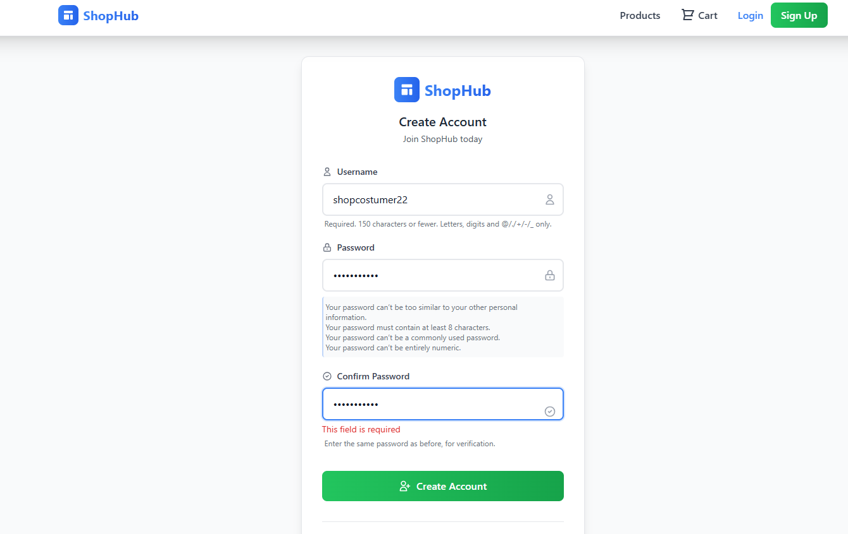
Figure 14: Testing user registration form validation.
The application checks password requirements such as minimum password length of 8 characters, no passwords that are frequently used and no passwords that are strictly pure numbers, as well as confirming passwords. Form validation is practiced by displaying an error message when the match with the confirm password field fails, giving the impression that this field is a mandatory field.
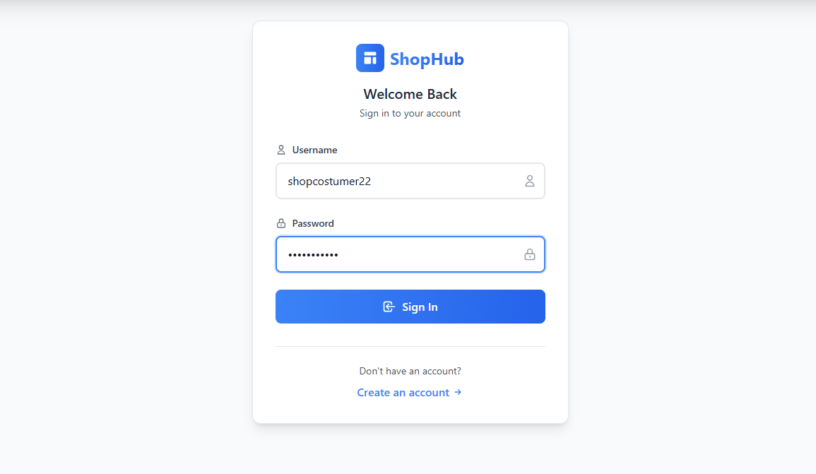
Figure 15: Testing the user authentication system.
Once the registration was postponed, attempted to enter using the shopcustomer22 user credentials (user name). This checks the login system and ensures that the information about the users has been uploaded appropriately into the database when registering them.
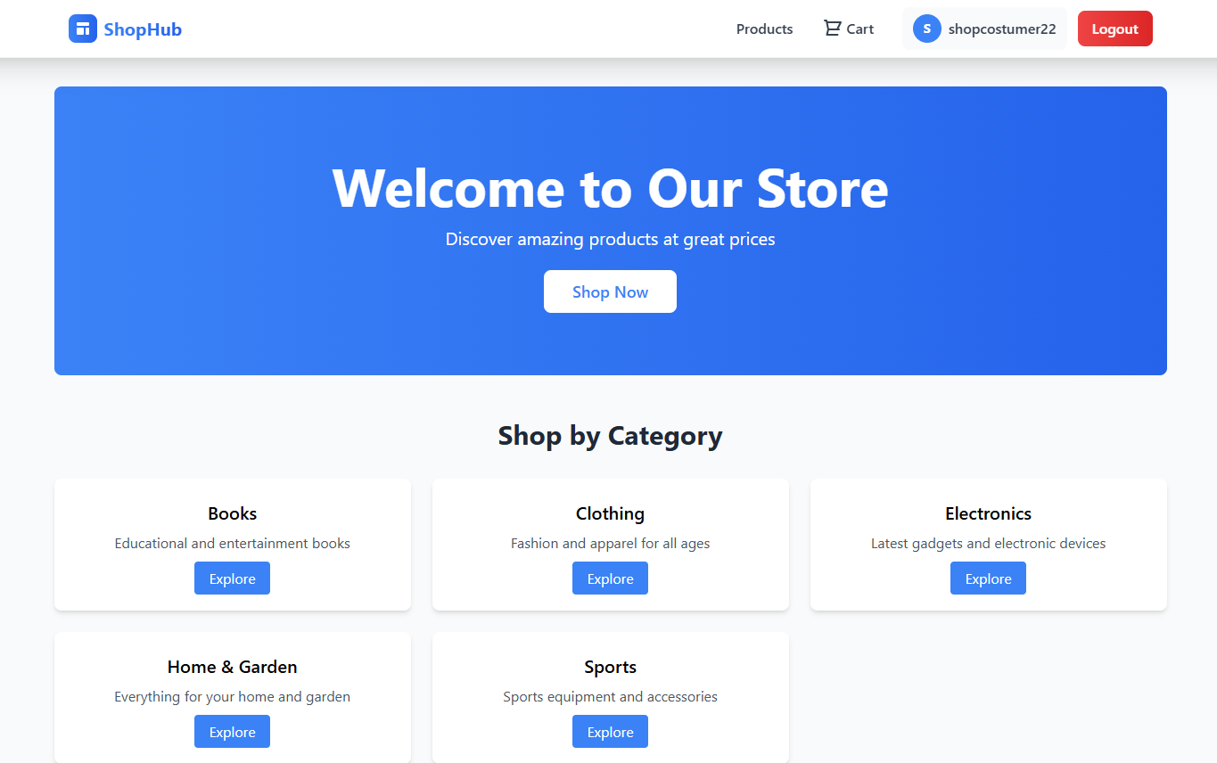
Figure 16: Testing successful user authentication and session management.
The user is redirected to the home page, and the authenticated session is activated with the authenticated username appearing in the menu and the logout option appearing, and the username displayed in the menu shopcostumer22, indicating that the authentication and creation of the authenticated session is successful.

6.1 Running in CI (already configured)
GitHub Actions can be automated tests addressing the logic of the application and database behaviour in a clean environment, and validate their correctness before being deployed as a pull request or merge. This moved the fault detection to a later stage in the lifecycle and minimized the chance of risk during deployment.
The objective of the tests was to be standalone, fast, and repeatable, and they needed a light data configuration and gave no external dependencies. Such common failures as migration drift, or stock validation have been detected by CI runs and fixed prior to production. All in all, automated testing increased confidence in frequently changing code and enabled continuous delivery through the pipeline of verified code.

7. Continuous Delivery (CD)
To realize Continuous Delivery in this project, the source control was promoted to production on a single, tested container image using an automated pipeline to ensure that the application would never be un-deployable.

7.1 Tools Used to Implement Continuous Delivery
Continuous Delivery would be configured with the help of such tools as GitHub Actions to build and test an application automatically, Docker to package our application as an immutable artifact, and Render to deploy the image of applications with environment-specific configuration injected on the fly (Docker, Inc., 2025).

7.2 Continuous Delivery Workflow
The creation and release of valid changes that have taken place in the main branch during the process of merging are done automatically without any human intervention. At deployment, the container will run a regulated boot sequence that adjusts the production application. This involves the implementation of database migrations and the gathering of statistics prior to the initiation of the application server. When any stage in such a process does not succeed, the deployment will automatically be stopped, and the currently running version will continue to operate. The behaviour makes sure that the unsuccessful releases will not affect service availability and is congruent with Continuous Delivery values of safety and reliability.

7.3 Deployment Safety and Rollback
Deployment safety was provided by immutable container images and platform supported roll back. Each release was made traceable to a specific commit and image tag, making it easy to quickly recover by redeploying a previously stable version of code without making changes to it (Humble & Farley, 2010).

7.4 Auditability and Traceability
End to end Traceability was achieved by associating each deployment to a specified git commit, CI run, and container image. The accountability, reproducibility and safe rollback that was enabled by this audit trail in case of an event.
Overall, Continuous Delivery helped to decrease the risk of releases, minimise downtime and bring in frequent, trustworthy updates following DevOps principles.

8. Monitoring and Logging
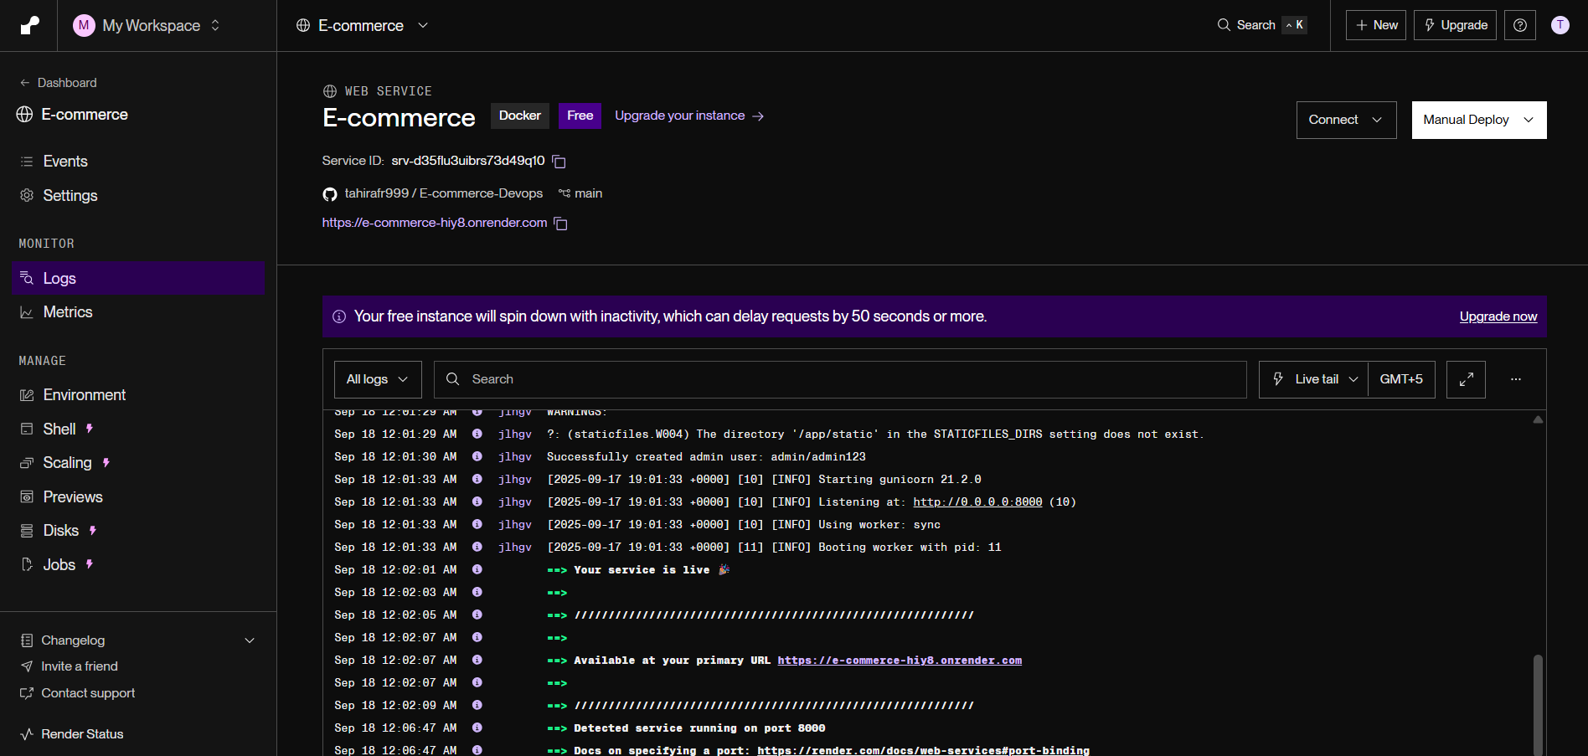
Figure 17: Render monitoring logs dashboard, where real-time logs confirm the Django e-commerce service is live, running on Gunicorn, and accessible via the deployed URL, providing visibility into application health and runtime events.
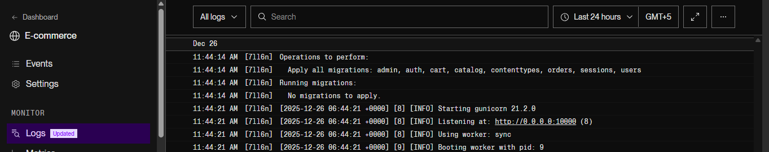
Figure 18: Continues Monitoring : This figure shows the live monitoring and logging system in action, where application events and operations are continuously tracked in real time. It helps administrators observe system behavior, verify successful processes, and quickly identify errors or performance issues, ensuring system stability and smooth ongoing operations.

8.1 Logging strategy
Logging was in a platform-native style where we had emitted structured application and server logs to standard output so that the hosting platform could eat up, store and surface operational events without any other tooling.

8.2 Using Render logs
Render logs were resorted to for diagnosing the failed deployment and runtime problems especially the configuration error like wrong configured environment variables or invalid host settings, which provides for rapid fault isolation.

8.3 Health and readiness
A lightweight health endpoint was added to confirm the application readiness and aid in verifying applications quickly during the deployments and restarts.

8.4 Minimal metrics without extra tooling
Basic service health was determined based on access logs and platform metrics which was enough to obtain proof of concept without adding extra monitoring complexity.

8.5 Worksflow incident and alerts.
Instances were managed consisting of having to go over live logs, redeploying the last known stable image, and documenting findings as GitHub issues for traceability & continuous improvement purposes.

8.6 Log hygiene and privacy
Log hygiene was enforced through omitting the inclusion of secrets or sensitive data so logs are safe to use for operational purposes and troubleshooting.

8.7 Common log patterns and fixes
Recurring problems like misconfigured hosts, database connectivity problems and static file handling problems were readable through logs and fixed through configuration or deployment fixes.
Even with the limitations of free-tier tooling, the result of the monitoring and logging approach gave us enough visibility to support stable operations and make informed improvements in the future.

Summary
Ipswich Retail proof of concept is a devops implmentation around the Django MVT based ecommerce app. Implementation of planning, architecture and deployment on Render containers. It uses Git Version Control, Auto CI/CD with GitHub Actions Docker images using GitHub Container registry, Runtime config using environment variables, archives PostgreSQL is used which is monitored by logs and health endpoints. This pipeline is a way of describing the transformation from a manual and monolithic system to an automated, observable and repeatable delivery process.
Lesson learned
Several lessons came out in the process of implementation. First of all, the containerisation and environment parity significantly decreased the number of configuration-related defects, although it was very important to design Dockerfiles and commands to start the environment correctly. Second, building test integrated in CI pipeline was crucial to be able to find regression issues early and move the quality checks earlier. Third, the use of a managed platform such as Render made the process of deploying and logging the platform easier, while making the trade-offs between convenience and control of the infrastructure.
Challenges
The main challenges with using it were handling limited free tier resources, reducing application cold start, handling configuration differences between development on my local system and production environment, reducing downtime during database migrations and rollbacks, and balancing the scope of e-commerce features with DevOps requirements.
Recommendation:
For complete deployment of Ipswich Retail, a few improvements are required. Connect the pipeline to a staging environment with a blue/green deployment and add a more detailed observability stack including metrics, dashboards, alert system, and others. Improve the handling of secrets and security testing Add central secrets store Automated SAST/DAST checks Over time moving to a flexible container platform such as Kubernetes or a multi-region setup could increase the availability and scalability while preserving the DevOps aspects in this proof of concept (Forsgren et al, 2018).

References
Django Software Foundation (2025) Django documentation (v5). Available at: https://docs.djangoproject.com/ (Accessed: 18 September 2025).
Docker, Inc. (2025) Dockerfile reference. Available at: https://docs.docker.com/engine/reference/builder/ (Accessed: 18 September 2025).
Forsgren, N., Humble, J., & Kim, G. (2018). Accelerate: The Science of Lean Software and DevOps. IT Revolution Press.
GitHub (2025) GitHub Actions: Workflow syntax & services. Available at: https://docs.github.com/actions (Accessed: 18 September 2025).
GitHub. (2025). GitHub Actions Documentation. GitHub, Inc. Retrieved from https://docs.github.com/en/actions
Gunicorn (2025) Gunicorn documentation. Available at: https://docs.gunicorn.org/ (Accessed: 18 September 2025).
Kim, G., Humble, J., Debois, P., & Willis, J. (2016). The DevOps Handbook: How to Create World-Class Agility, Reliability, and Security in Technology Organizations. IT Revolution Press.
Humble, J., & Farley, D. (2010). Continuous Delivery: Reliable Software Releases through Build, Test, and Deployment Automation. Addison-Wesley Professional.
OWASP (2025) OWASP Cheat Sheet Series (Django, authentication, logging). Available at: https://cheatsheetseries.owasp.org/ (Accessed: 18 September 2025).
Reitz, K., et al. (2025). The Hitchhiker's Guide to Python: Best Practices for DevOps. O'Reilly Media.
Render (2025) Render YAML and Docker deploys. Available at: https://render.com/docs (Accessed: 18 September 2025).
Render. (2025). Render Documentation. Render. Retrieved from https://render.com/docs
Sketching, F., ge8152 engineering graphics ltpc. Affiliated institutions b. Tech Information Technology Regulations–2017 Choice-Based Credit System Program Educational Objectives (PEOs), 5, p.31.
The PostgreSQL Global Development Group (2025) PostgreSQL 15 documentation. Available at: https://www.postgresql.org/docs/15/ (Accessed: 18 September 2025).
The Twelve-Factor App (n.d.) 12factor.net. Available at: https://12factor.net/ (Accessed: 18 September 2025).
WhiteNoise (2025) WhiteNoise documentation. Available at: http://whitenoise.evans.io/en/stable/ (Accessed: 18 September 2025).

Appendix:
GitHub link
https://github.com/tahirafr999/e-commerce
Website live link:
https://e-commerce-hiy8.onrender.com/

